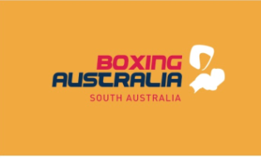

Dear Coaches,
Attached are your registration forms for 2023, which include your Club Registration form, Coaches, Competitors, and Non-Competitors registration forms. BSA Committee have kept the fees the same as 2022
Registrations are due as of 1st January 2023. Your registrations are for the period of January 1st to December 31st. Please remember you’re Club, coaches and boxers are not covered by insurance until you have paid your registrations. Once Club registrations have been paid your Club details will be uploaded on the Boxing SA website.
You can pay your registrations by cash, cheque, Eftpos or electronic transfer. If you EFT your payments can you, please place a reference name so Boxing SA knows that those funds have come from you. Can you also post your registration documents to Boxing SA 132 Rose Terrace Wayville 5034 or P.O box 584 Loxton SA 5333 or you can email them to ally@boxingriverland.com.au or BSA secretary Heather Hughes hethandtony@gmail.com

The Boxing SA bank account details for electronic payments are:
BSB: 105 001
Acc: 136572440
Name: Boxing SA Inc

Boxing SA wishes you all a Merry Xmas and a Happy New Year and we are looking forward to a great and busy 2023 season.

